14 Masking in Color Panel
Find the Power window tab, select square
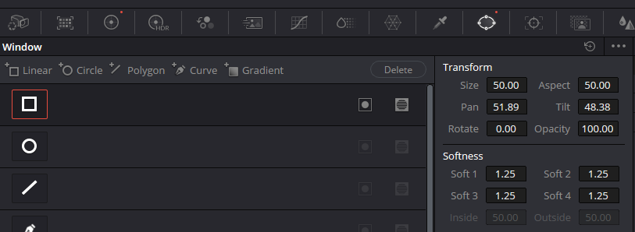

Fit it
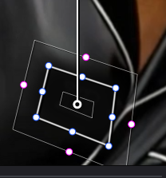
You will want to move these color wheels, to match or cover up something that needs to be covered. In our instance, we wanted to remove a logo, and turn the logo to match the color of the shirt. If this is a problem, you can also add a patch of color in a clip on the timeline above this clip. And use that to cover up the trade mark.
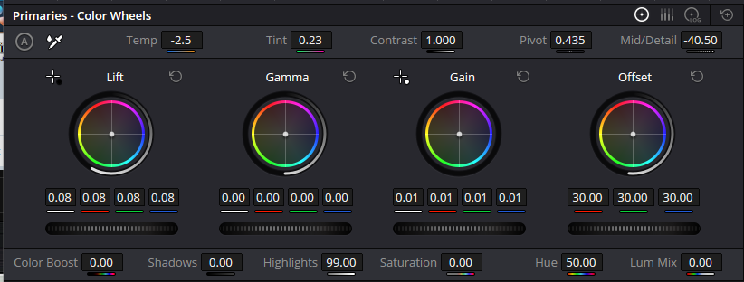

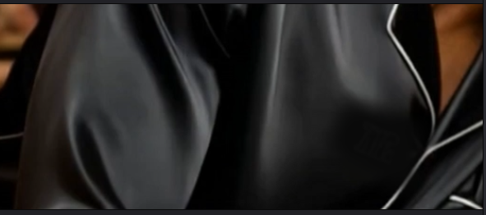

Tracker
The color panel has its own tracker. As the movie plays, it should track and move with the area that you have targeted with the Power window.

You will need to hit this button here on the color page, to be able to get to the tools used to track something.
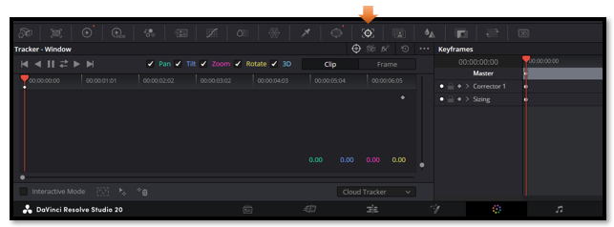
First hit the Tracker button at the top of this window to op
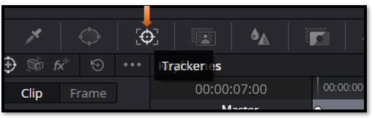
Then hit the track forward button here.
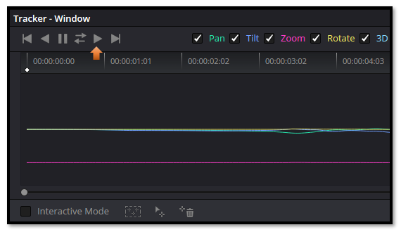

As the movie plays it will track the logo throughout any movements that is made. This means that no matter how the man moves in the clip, the tracker will automatically keep the power window covering this logo area, and keep the logo completely covered with the color that we used to mask the emblem.

The Other Tracking Buttons
You will notice that we have other options that we can use besides the Track forward button that we did.

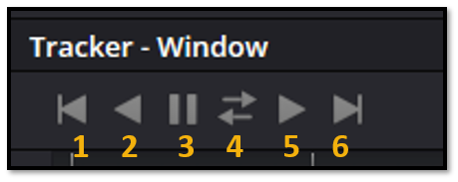

- Track one Frame Reverse (more control tracking one frame at a time)
- Track Reverse
- Stop Tracking
- Track Forward and Reverse
- Track Forward
- Track one Frame Forward

